**Project Identification**

| **Project:** | Group T24 - GBCoders |
| --- | --- |
| **Prepared By:** | Chi Calvin Nguyen |
| **Document Version:** | 1.1 |
| **Published Date:** | October 8, 2021 |

**Contributors**

| **Name** | **Title** |
| --- | --- |
| Chi Calvin Nguyen | *Project Developer* |
|  |  |

**Distribution**.

| **Name** | **Title** |
| --- | --- |
| Aryan Luthra | *Project Developer* |
| James Weber De Asis | *Project Developer* |
| Simon Ung | *Project Developer* |

**Referenced Documents**

| **Version number** | **Title** | **Author** | **Date** | **Source / Location** |
| --- | --- | --- | --- | --- |
|  |  |  |  |  |
|  |  |  |  |  |
|  |  |  |  |  |

**Revision History**

| **Version Number** | **Revision Date** | **Summary of Changes** | **Modified by** |
| --- | --- | --- | --- |
| *0.1* | *10/1/2021* | *Initial Draft* | Chi Calvin Nguyen |
| *1.0* | *10/4/2021* | *Final Version* | Chi Calvin Nguyen |
| 1.1 | 10/8/2021 | Minor adjustments (spelling etc.) | Chi Calvin Nguyen |

**TABLE OF CONTENTS**

***1.*** ***BUSINESS CONTEXT DIAGRAM 3***

***2.*** ***REQUIREMENTS SCOPE STATEMENTS 4***

***3.*** ***HIGH LEVEL BUSINESS REQUIREMENTS SIGN-OFF 4***

1. **Business Context Diagram**

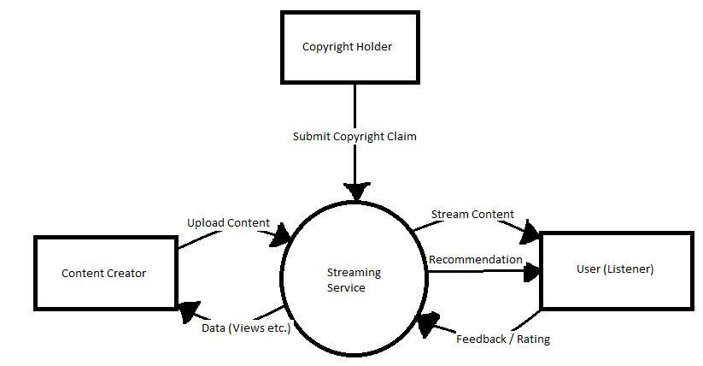

| **Requirement Scope Area** | **Description** |
| --- | --- |
| Streaming Service | Deliverable product of the project where users can upload and manage their content, discover content on the service, and stream content from the service in varying sound qualities. |

| **External Entity** | **Description** |
| --- | --- |
| Copyright Holder | Organization or persons who possess the copyright of a piece of content legally or illegally uploaded onto the service. |
| User (Listener) | User accesses platforms resources such as streaming music, managing their content, and alters recommendations based on feedback |
| Content Creator | Content creators upload their content and receive data on their content such as number of views etc. |

| **Information Flows** | **Description** |
| --- | --- |
| Submit Copyright Claim | Copyright claim is submitted for the take down of content on the system |
| Stream Music | Audio files are sent remotely from the system to the user’s client |
| Recommendation | Content recommended to user based on their feedback and preferences |
| Feedback / Rating | User’s feedback to the system, it can apply to songs, artists, playlists, and albums |
| Upload Content | Content uploaded to the system which can be streamed to remote users |
| Data (Views etc.) | Includes data for the content creator such as number of views where the content creators can make judgements based on the data. |

1. **Requirements Scope Statements**

| **HLR#** | **Description** | **Priority**  **(H, M, L)** |
| --- | --- | --- |
|  | Users must be able to listen to their desired content locally or online if they have an internet connection | H |
|  | Users must be able to change the bitrate quality of the content they are streaming from the service | H |
|  | Content creators must be able to upload their content onto the system if they possess an account | H |
| HLR04 | Users must be able to give feedback on content to improve their content recommendations | L |
| HLR05 | Users must be able to add content to a playlist to filter the content they want at a given time | H |
| HLR06 | Content creators must receive data on their uploaded content to make judgement on what content to create | M |
| HLR07 | Copyright Holder must be able to submit a copyright claim on specific content on the service to be taken down | H |
| HLR08 | Content Creators must be able to manage their content, such as deletion or editing specific factors (such as titles). | M |

1. **High Level Business Requirements Sign-Off**

*The undersigned acknowledge their agreement with the contents of Version <*1.0*> of the* High-Level *Requirements document for <Music Streaming System with Mobile Music Player App>*.

*Following approval of this document, requirements changes will be governed by the project’s change management process, including impact analysis and appropriate reviews and approvals, under the general control of the Project Plan and according to company policy. Approved Change Request Documents, if present, will be attached to this Requirements Document as updates.*

| **Name** | **Project Role and**  **Functional Area** | **Date Signed** |
| --- | --- | --- |
| James Weber De Asis | Project Developer | 10/04/2021 |
| Simon Ung | Project Developer | 10/05/2021 |
| Aryan Luthra | Project Developer | 10/05/2021 |

*\* Note: physical signatures are not required. Email approvals are acceptable and should be appended to project documents.*